- I Decided to add some Bullet Point Explanations on what I did for this project.

- First, I tried to run the project given to me. 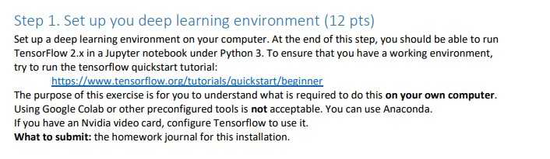



- I ran into an issue where I run into the error “No Module named ‘tensorflow’”

- I then YouTube how to install tensorflow for Anaconda (And since the first part of the project is setting up a deep learning environment)

- **Bingo!** (*Shoutout to Niam Yaraghi*)

- I create A new environment in Anaconda and call it “**tf**”, then I install **TensorFlow**, **myplotlib**, and **Keras.**



- I then use the **Anaconda Navigator** to launch from my created environment



- I am now able to run the python file provided.



- So now that I created my TensorFlow environment, on to step 2 of the project.

- I followed instructions and unzipped the file.

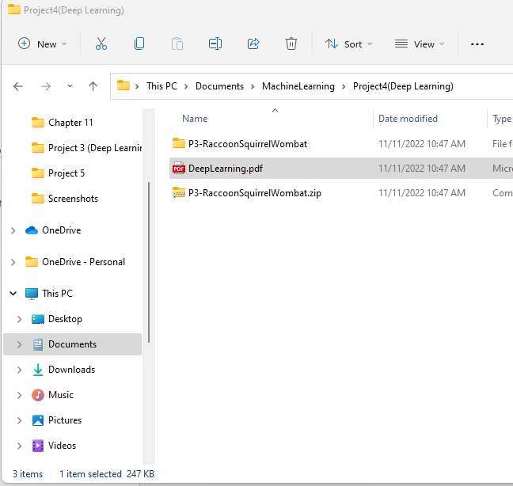

- I am Then Asked to screenshot the results from my journal



